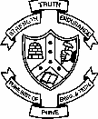**College of Engineering, Pune**

**(An Autonomous Institute of Government of Maharashtra)**

Applied Science Department

**CT16002 – Biology for Engineers**

**UNIT V: Complex processes- Transport, communication and Defense**

**-------------------------------------------------------------------------------------------------------------**

# Transport Phenomena in Biological Systems:

Membrane, channels and ion channels; Fluid flow and mass transfer

* 1. In plants: Xylem and Phloem
  2. In animals: Blood and Lymph
  3. Transport of molecules and gases (Oxygen and Carbon dioxide)
  4. Heat Transport - Body temperature regulation

1. **Communication:** Cell junctions, Cell-cell communications – cell signaling, Hormones, Pheromones; Chemotaxis. Communication in living systems by photo, bio, chemotactic methods.

# Defense mechanisms in plants and animals:

* 1. In plants: Herbivory, secondary metabolites.
  2. In animals: Innate and Adaptive immune systems.

# Background:

**Plasma Membrane**

Also called as biomembrane, plasmalemma., unit membrane, cell membrane. Cell membrane & cell organelle membrane have same ultra structure.

Plasma membrane is thin, transparent, elastic, porous, semi fluid, dynamic, living, protective, semi permeable, regenerative, 5-8 nm thick

Chemical composition:-- Vary in different cells. But generally Proteins – 58 – 75 % Structural – form back bone of cell mem. Carrier (trans membrane) – for transport of substances

Lipids – 20 – 40 % e.g. lecithin, cholesterol, galactolipid, phospholipid Carbohydrates – 2 -5 % glucose, glucosamine.

# Fluid Mosaic Model by Jonathan Singer and Garth Nicholson.

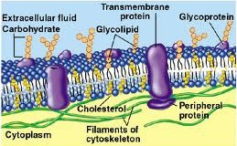

1. Most accepted model up till now. Describes as “ **protein icebergs in lipid sea**”. Based on chemical analysis, biophysical properties of membrane
2. Plasma membrane is lipoprotein, trilamellar / trilaminar in nature.
3. Phospholipid bilayer – same as in above 2 models. It is fluid in nature. Phospholipid molecules exhibit 3 types of movements.
   1. **Transition movement** – molecules move laterally in the same monolayer changing position within same layer. It is frequent.
   2. Rotational movement – individual lipid molecules rotate very rapidly about their long axis.

b. **Flip – flop movement** – molecules of 2 layers inter change position. It is not so frequent

1. Proteins are globular, of 3 types. i. e. **Extrinsic / peripheral proteins** – lie outside to the phospholipid layer, loosely / non-covalently attached to phospholipid mole. of exoplasmic surface of pl. mem., hence can be easily removed in aqueous soln. Present 30 %. e. g. Acetylcholinesterase, ATPase, Spectrin.
2. **Intrinsic proteins** – covalently attached to phospholipid mole. of cytosolic surface of pl. mem., hence strongly held to these mole., not easily separable. These are 70 %, if separated, become insoluble in aqueous soln. e. g. Cytochrome oxidase (from mitochondria.), rhodospin (from retinal rod cells)
3. **Channel / Tunnel / Transmembrane / Integral proteins –** Large sized, extend across bilayer on both surfaces of phospholipid bilayer as single α helix / β sheet or barrels E. g. glycoproteins. Act as charged channels for transport of H 2O – sol. Materials, ions and H2O along conc. gradient & against conc. gradient. e. g. enzymes in mitochondria. Receptors in hormones. Permease in selective transport

Function -- Proteins provide structural, functional specificity to cell mem., elasticity, mechanical support . Proteins on both surfaces show functional differences.

1. Oligosaccharides – molecules covalently attached with outer surface and form glycolipids with lipids. e.g. sialic acid. & glycoproteins with proteins, may extend in extra cellular fluid & form a zone called glycocalyx. Due to these molecules membrane becomes asymmetric.

Function – cell recognition, imp. role in blood grouping, blood clotting , immune response, cell to cell adhesion, tissue rejection, inflammation process, prevent unwanted protein protein interaction between adjacent cells, protect cells from mechanical & chemical damage.

1. In animal membrane sterol molecule – like choesterol between phospholipids that are rigid and provide stability & maintain fluidity of membrane, tighten packing of lipids..
2. Cytoskeletal filaments of actin present towards cytosolic surface.

Function -- give support to membrane & restrict diffusion of membrane proteins.

# Importance of above model ---

1. Quasi – fluid state of biomembrane. Hence membrane can undergo dynamic changes. (renewed, removed, folded), variations in form, size, shape are possible.
2. Two distinct surfaces of plasma membrane because phospholipids in outer layer with oligosaccharides

Cytosolic – facing the cytoplasm,

Exoplasmic – facing the inter cellular atmosphere

Glycoproteins, Glycolipids form glycocalyx which is found only on exoplasmic surface.

1. As proteins are in mosaic pattern membrane is not rigid.

# Experiment to demonstrate fluid nature of cell membrane

Mouse cell + green fluorescent Ab.  cell with green fluorescent Ab on surface

A

Human cell + red fluorescent. Ab.  cell with red fluorescent Ab on surface

B

Fusion of A + B  

i.e.Somatic hybridizaton

Heterokaryon Heterokaryon .

At 0 C At 37 C

No mixing of Ab Mixing of Ab as

as lipids are solid lipids are liquid at at 0 C 37C

( Heterokaryon – hybrid cell with fused cytoplasm, but nuclei separate.)

When lipids are mixed with water 3 types of lipid aggregates can form ----

1. Micelles – spherical structures with monolay er
2. Bilayer – as in pl. membrane
3. Liposomes – lipid bilayer folded with aqueous cavity inside

# Functions of Plasma membrane :

1. Maintain individuality, forms cell, organelles.
2. Cell becomes dynamic, regulate flow of material, energy in and out of cell.
3. Cell contents separated from external environment and cell environment.
4. Protect from injury
5. Forms new sub – cellular organelles like endoplasmic reticulum, golgi complex.
6. Controls cellular interactions req. for tissue formation, defense against microbes entry.
7. Imp. role in blood groups, immune response, organ transplant.
8. Selective permeability – due to enzymatic activity.
9. Helps in maintaining transport and permeability of cell through – osmosis, diffusion, active transport.
10. Concern with cell adhesion, maintaining cell shape, cell rigidity,
11. Pseudopodia, cilia, flagella formed of plasma membrane help in cellular movement.
12. Release of secretions, wastes by exocytosis.
13. Nerve impulse transmission.
14. Inner membrane of mitochondria, mesosomes contain electron transport chain of respiration.
15. Infolds carry endocytosis, pinocytosis, phagocytosis. Outfolds increase absorptive surface area.

Membrane Transport

**Active Passive Bulk**

Direct Indirect

Simple Diffusion

Facilitated Diffusion

Exocytosis Endocytosis

**Carrier Proteins**

* + Uniport
  + Symport
  + Antiport

**Ion Channels**

* Voltage
* Ligand
* Mechano- sensitive

# Transport Mechanism: Passive, Active and Bulk

**A] Passive Transport** –

* Bidirectional, along conc. gradient, no E. used, slow process

# Diffusion -

* Dependent upon no. of particles per unit vol., density of med., distance thro’ which it occurs, temp., pressure.
* If 2 subs. don’t react, then diffuse independently. Gas mole. move along pressure gradient

Non – electrolytes move along - conc. gradient Ions move along electro – chemical gradient

* + Most of the substances move across membranes in the form of one ion / molecule e.g.

Na+, K+, Ca++, Cl-, H+, sugars, amino acids, nucleotides.

* + Concentration of these substances most of the times higher inside cell / cell organelle than outside.
  + For cell, membrane transport is important because 20 % of genes in E.coli are identified as involved in some aspect of transport.
  + Diffusion is always movement toward equilibrium i.e. it tends toward minimum free energy.

(As against chemical reactions and physical processes which always proceed in the direction of decreasing free energy according to 2 nd law of thermodynamics.)

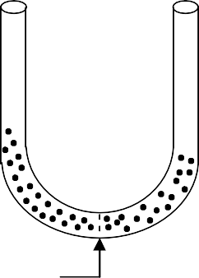Mem. permeable to solute



(In membrane transport free energy change depends on conc. / electrochemical gradient but also on heat, pressure, entropy. There diffusio n always proceeds from regions of higher to lower free energy. At thermodynamic equilibrium when free energy of the system is at minimum no further net movement occurs.)

* + Thermodynamically diffusion is exergonic process as requiring no input of metabolic E

E.g. Dialysis, Filtration, respiration in animals due to diffusion of gases from blood to alveoli and vice versa, Uniform distribution of materials in cytoplasm.In animals sexual act, territory marking due to diff usion of phermones. (special hormones in animals)

# Osmosis –

Special diffusion of H2O or solvent

* Operates always in liquid media
* Only solv. part of solution diffuses, not solute, through differentially permeable membrane.
* Depends on no. of solute particles.
* Opposed by turgor or hydrostatic pressure.
* Types of Osmosis –

1. Endosmosis – entry of solvent into cell, animal cell swells & bursts due to excessive endosmosis –i.e. plasmolysis, plant cell becomes swollen/t urgid, due to cell wall it does not burst
2. Exosmosis – exit of solvent from cell, animal cell shrinks, plasma membrane of plant cell shrinks from cell wall due to excessive exosmosis & turgid / swollen cell shrinks / becomes flaccid.

# Hydrostatic / Turgor pressure –

Due to endosmosis pressure exerted by protoplast on pl. membrane, cell wall is called as turgor pressure.

**Osmotic pressure** – Maximum hydrostatic pressure required to resist osmotic flow of H 2O into solution., when solution. is separated from pure H2O by differentially / selectively permeable membrane. Higher is solute conc. in soln. higher is osmotic pressure. It is measured by osmometer.

**Tonicity** – Tension / stress developed in a system due to presence of osmotically active substance in it.

**Isotonic solntion** – solute conc. of extra and intra cellular fluid is same, hence no osmosis. e. g. mammalian RBC (other then human) in 0.9 % NaCl solution, human RBC in 5 % glucose solution.

**Hypertonic solution –** solute concentrat ion of extra cellular fluid > intra cellular fluid, hence exosmosis occurs. e.g. Cells shrinks in 2 % NaCl, 10 % Glucose solution. e. g. plasmolysis, wrinkles, crenation.

# Hypotonic solution –

solute conc. of extra cellular fluid < intra cellular fluid, he nce endosmosis occur, cell swell e.g. RBCs in distilled H2O swell, finally burst , result in Ghost of RBCs. 0.5 % Nacl, 3 % Glucose.

# ♣ Significance of osmosis-

1. Soil H2O enters root cells.
2. Turgidity in living cells maintained.
3. Due to turgidity, soft parts like leaves, fruits., flowers remain stretched.
4. Germination of seed occurs,resulting in growth of radicle, plumule.
5. Plant move.
6. Opening, closing of stomata(openings in leaves)

Hypertonic soln.

Isotonic soln.

Hypotonic soln.



|  |  |  |
| --- | --- | --- |
| Shrinking | Animal cell | Plasmolysis |
|  | Normal |  |
| Only pl.mem. | Plant cell | No change |
| shrinking |  |  |

<------------- ------------>

* Substances too large / too polar can move into / out of cell / cell organelle at appreciable rates only with the help of transport protein. If solutes still diffuse do wn the conc. gradient without input of energy then it is facilitated diffusion.

E.g. conc. of glucose higher in blood than in RBC, so transport of glucose across the plasma membrane of cell is no doubt passive, but glucose is too large, too polar to diffus e across the membrane unaided; hence transport protein is required to facilitate its inward movement.

* Transport proteins are transmembrane segments, hence travevse (turn horizontally) the membrane several times.

1. Types –

# 1) Carrier proteins / Transporters / Permeases –

* Bind 1 / more solute molecules on one side of membrane, then undergo conformation (structure ) change to transfer the solute on other side of membrane. (proposed by S.J. Singer)
* Probably carrier protein shields the polar / charged group of solute from non – polar interior of the membrane.

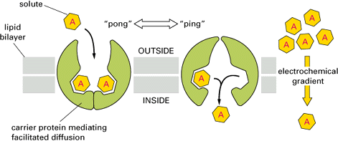

# Types of Carrier Protein Transport-

1. **Uniport Transport** – transport of single solute.
2. **Cotransport / coupled transport** – simultaneous transport of 2 solutes, both solutes necessary for transport i.e. obligatory. Types
3. **Symport** – if both solutes move in same direction (as shown in diagram)
4. **Antiport** – if both solutes move in opposite direction.(as shown in diagram) Both ways transport of H 2O takes place.

(Facilitated diffusion is possible in animal cells due to low glucose concentration because incoming glucose is quickly phosphorylated (addition of PO4 ) to glucose – 6 – PO4 by hexokinase with ATP as PO4 donar and energy source.)

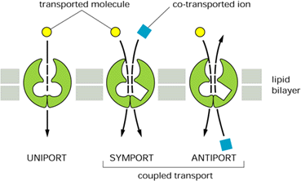

# Erythrocyte Anion Exchange Protein – Antiport Carrier

* By antiport carrier protein chlorid – bicarbonate exchange facilitates reciprocal exchange of Cl and HCO3 ions across the membrane in 1 : 1 ratio in obligatory manner.
* In cell if HCO3 conc. is high., binding site of anion exchange protein binds to HCO 3 ion on inner surface and Cl ion on outer surface; reverse will happen when in cell HCO 3 conc. is low.
* Same way transport of CO 2 from tissues into erythrocytes by converting it into HCO 3 ions takes place.

# 2) Channel Proteins –

* Form hydrophilic channels through membrane to allow the passage of solutes without any change in conformation of protein.
* E.g. pores found in outer membrane of bacteria, mitochondria, chloroplast. They are formed by transmembrane proteins e.g. porins, allow selected hydrophilic solutes with molecular wt. up to 600 Dalton to pass through.
* Most of these channel proteins involved in transport of ions rather than m olecules, hence called as **ion channels**.
* As no conformational changes necessary, movement of solutes through ion channels is much rapid than carrier proteins..

# Channel Proteins Facilitate Diffusion by Forming Hydrophilic Transmembrane Channels

* By forming hydrophilic transmembrane channels, channel proteins allow ions to move across the membrane directly.

# Types of Channel Proteins – ion channels, porins and aquaporins.

1. **Ion channels-**

* Ion channels are highly selective, allow passage of only one kind of ion. Hence separate channels for each in Cl, Ca++, Na+, K+ transport.
* Selectivity is due to binding sites & constricted center acting as a filter.
* A single channel can conduct almost 1000000 ions / sec.
* Most ion channels are gated i.e. they can be opened and closed by conformational changes in the protein, thus regulate ions flow through channel.
* In animal cells 3 kinds of stimuli control opening and closing of gated channels. I Membrane potential – Control voltage gated channels.

1. Specific substances – Control ligand gated channels.
2. Mechanical force – Control mechano sensitivee channels.

# Porins –

* Pores in outer membrane of bacteria, chloroplast, mitochondria are formed by porins.
* X – ray crystallography reveals that porins present in the form of  sheet called  barrel and not  helix has a water filled pore at center, polar side chains are lining inside pore, non - polar side chains at outside of barrel that interact with hydrophobic interior of the membrane.

# Aquaporins –

* Allow all H2O moles to pass but not any other polar subs.
* Or continual movement of membrane lipids create transient holes in lipid monolayers to allow H2O molecules to move first through monolayer and then through the others.
* Facilitate rapid movement of H2O molecules into or out of cells in specific tissues (not all)

e.g. PCT ( present in kidney ), erythrocytes.

* Size 0.3 nm. (just large enough to pass H2O molecule one at time.)

# Active Transport – (Protein Mediated Movement Up the Gradient )

It moves solutes away from thermodynamic equilibrium (i.e. Up/against the concentration or electrochemical gradient) and hence always requires an input of energy. Thus thermodynamically it is unfavorable (endergonic) and occurs only when coupled with an exergonic process. Therefore membrane proteins involved in active transport must provide mechanism for moving desired solute molecules across the membrane as well as for coupling such movements to energy yielding reactions.

* Due to active transport following pr ocesses take place

1. Uptake of essential nutrient from surrounding fluid / environment against concentration gradient.
2. Removal of waste products, secretory products from cell or cell organelles against concentration gradient also.
3. Non equilibrium intracellular concentration of specific inorganic ions, notably K +, Na+, Ca++, H+ maintained constant.

# Indirect Active Transport –

* It is co-transport of 2 solutes, one down its gradient, another up its gradient.
* Out of 2 solutes, mostly one is an ion (usually Na+ / K+) which moves exergonically down its electrochemical gradient driving second solute (amino acid, monosaccharide against its concentration gradient.)
* For animal cells Na+ symport is usual option.

# Direct Active Transport –

In this transport accumulation of solute molecules / ions on one side membrane is coupled directly to an exergonic reaction, most commonly hydrolysis of ATP.

Transport proteins driven directly by ATP hydrolysis are called transport ATPases or ATPase pumps. 4 types of transport ATPases – P – type, V – type, F – type, ABC – type

* Above 4 types differ in structure, mechanism, localization and role but mostly move Na +

outward across plasma membrane of the cell.

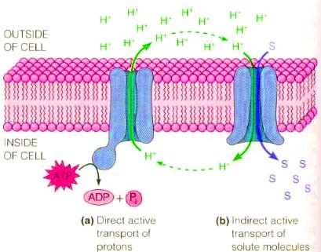

# Applications of cell membrane:

1. **Based on biosignaling:**
2. Detection and identification of biological warfare agents – artificial ion channels are made which are sensitive to pathogen and detect and identify the pathogen. E.g. *Yersinia pestis* (causes plague), *Bacillus anthrasis*

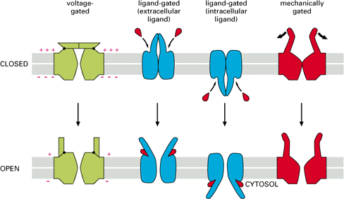(causes anthrax)

1. Drugs for modulating (regulating) ion channels with therapeutic (pertaining to therapy) potential – voltage gated ion channels are potential therapeutic agents in cardiovascular disorders and ligand gated in nervous system disorders.
2. Developing molecular device for live cell kinetic method for screening of neuro -transmitter uptake by cell.
3. Ion channel assay (potency determination)system using ion selective optical nano -sensors is used to determine drug potency.

# Liposome based:

1. Liposome kit for DDS – Custom-made synthesis of highly purified synthetic phospholipids provide liposome kit for DDS(Drug Delivery System)
2. Delivering anti-cancer drugs like vincristin in liposomes to treat lymphoma and other cancers for more efficient targeting and delivery.
3. Cell membrane modifier – Using biocompatible anchor formembrane, cell membrane can be modified without causing damage and cells can be immobilize alive on surface of various materials.
4. Gene therapy – For targeting cells with defect, liposomes containi ng specific antigen (disease marker) & immunostimulatory DNA molecule is used.
5. Cosmetic liposomes – They have good stability in cosmetic products, excellent dry feeling on skin, enhance penetration into skin. Physiologically active materials such as ant iageing, skin whitening, moisturing agents are stably encapsulated.

**Different mechanisms transport substances over short or long distances**

Given the diversity of substances that move through plants and the great range of distances and barriers over which such substances must be transported, it is not surprising that plants employ a variety of transport processes. Before examining these proces ses, however, we will look at the two major pathways of transport: the apoplast and the symplast.

Plant tissues may be viewed as having two major compartments —the apoplast and the symplast. The **apoplast** consists of everything external to the plasma membranes of living cells and includes cell walls, extracellular spaces, and the interior of dead cells such as vessel elements and tracheids. The **symplast** consists of the entire mass of cytosol of all the livi ng cells in a plant, as well as the plasmodesmata, the cytoplasmic channels that interconnect them.

The compartmental structure of plants provides three routes for transport within a plant tissue or organ: the apoplastic, symplastic, and transmembrane rou tes. In the *apoplastic route*, water and solutes (dissolved chemicals) move along the continuum of cell walls and extracellular spaces. In the *symplastic route*, water and solutes move along the continuum of cytosol. This route requires substances to cross a plasma membrane once, when they first enter the plant. After entering one cell, substances can move from cell to cell via plasmodesmata. In the *transmembrane route*, water and solutes move out of one cell, across the cell wall, and

into the neighboring cell, which may pass them to the next cell in the same way. The transmembrane route requires repeated crossings of plasma membranes as substances exit one cell and enter the next. These three routes are not mutually exclusive, and some substances may use more than one route to varying degrees.

**Temperature Regulation of the Human Body**

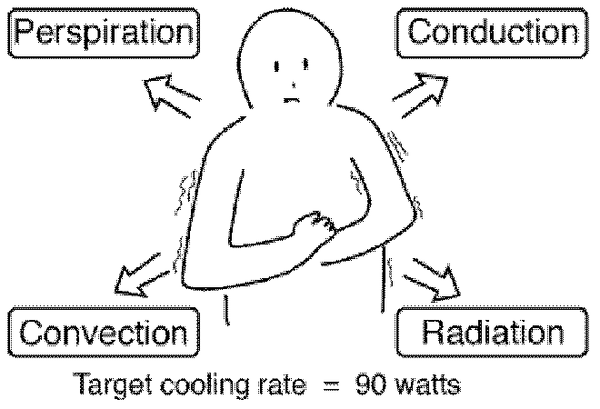The human body has the remarkable capacity for regulating its core temperature somewhere between 98°F and 100°F (36.60C to 37.70C) when the ambient temperature is between approximately 68°F and 130°F (20.00C to 54.40C) according to Guyton (This presumes a nude body and dry air).

The external heat transfer mechanisms are **radiation**, **conduction**, **convection** and **evaporation of perspiration**. The process is far more than the passive operation of these heat transfer mechanisms, however. The body takes a very active role in temperature regulation. The temperature of the body is regulated by **neural feedback mechanisms** which operate primarily through the **hypothalmus**. The hypothalmus contains not only the control mechanisms, but also the key temperature sensors. Under control of these mechanisms, sweating begins almost precisely at a skin temperature of 37°C and increases rapidly as the skin temper ature rises above this value. The heat production of the body under these conditions remains almost constant as the skin temperature rises.

If the skin temperature drops below 37°C a variety of responses are initiated to conserve the heat in the body and to increase heat production. These include

* + Vasoconstriction to decrease the flow of heat to the skin.
  + Cessation of sweating.
  + Shivering to increase heat production in the muscles.
  + Secretion of norepinephrine, epinephrine, and thyroxine to increase heat pro duction
  + In lower animals, the erection of the hairs and fur to increase insulation.

# Cooling of the Human Body

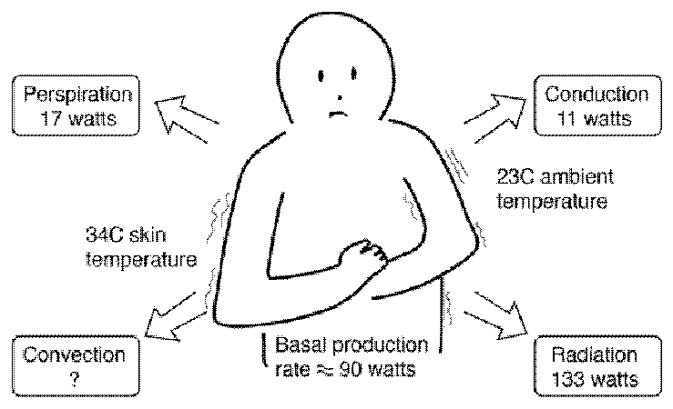

This is a simplified model of the process by which the human body gives off heat. Even when inactive, an adult male must lose heat at a rate of **about 90 watts** as a result of his basal metabolism. One implication of the model is that radiation is the most important heat transfer mechanism at ordinary room temperatures. This model indicates that an unclothed person at rest in a room temperature of 230C or 73 Fahrenheit would be

uncomfortably cool. Select one of the cooling mechanisms for further details about how the model numbers were obtained. The skin temperature of 34 0C is a typical skin temperature taken from physiology texts, compared to the n ormal core body temperature of 370C.

Even when inactive, an adult male must lose heat at a rate of about 90 watts as a result of his basal metabolism. This becomes a problem when the ambient temperature is above body

temperature, because all three standar d heat transfer mechanisms work against this heat loss by transferring heat into the body. Our ability to exist in such conditions comes from the efficiency of cooling by the **evaporation of perspiration**.

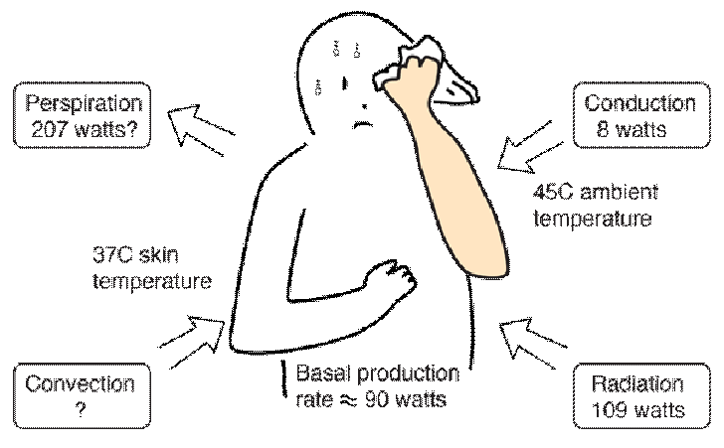At a temperature of 113 Fahrenheit (45 0C) the evaporation process must overcome the transfer of heat into the body and give off enough heat to accomplish a 90 watt net outward flowrate of energy. Because of the body's temperature regulatory mechanisms, the skin temperature would be expected to rise to 37°C at which point perspiration is initiated

and increases until the evaporation cooling is sufficient to hold the skin at 37°C if possible. With those assumptions about the temperatures, the Stefan -Boltzman law for an area of 2 m 2 and emissivity 0.97 gives a net input power of 109 watts to the body. The perspiration cooling must overcome that and produce the net outflow of 90 watts for equilibrium.

The transfer of heat is normally from a high temperature object to a lower temperature object. Heat transfer changes the internal energy of both systems involved according to the Ist law of Thermodynamics.

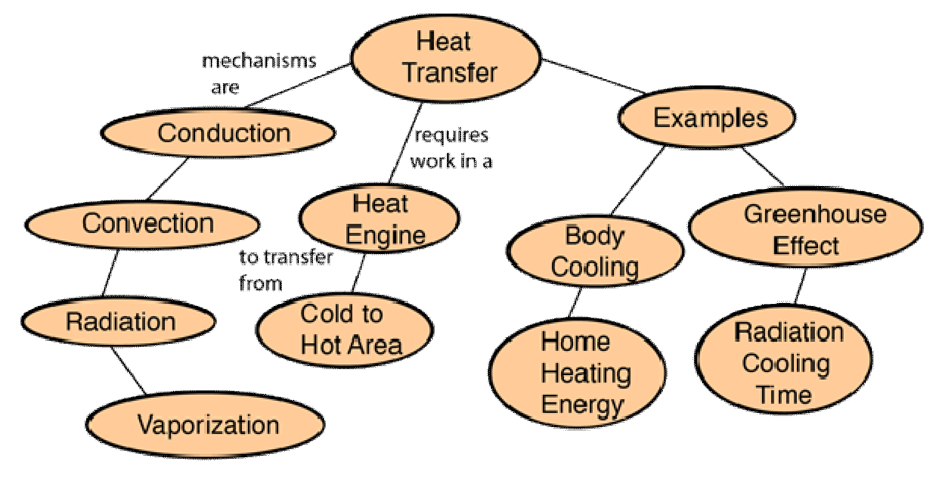

# Heat Conduction

Conduction is heat transfer by means of molecular agitation within a material without any motion of the material as a whole. If o ne end of a metal rod is at a higher temperature, then energy will be transferred down the rod toward the colder end because the higher speed particles will collide with the slower ones with a net transfer of energy to the slower ones. For heat transfer between two plane surfaces, such as heat loss through the wall of a house, the rate of conduction heat transfer is:

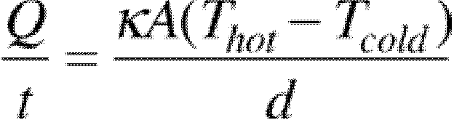





# Stefan-Boltzmann Law

= heat transferred in time =

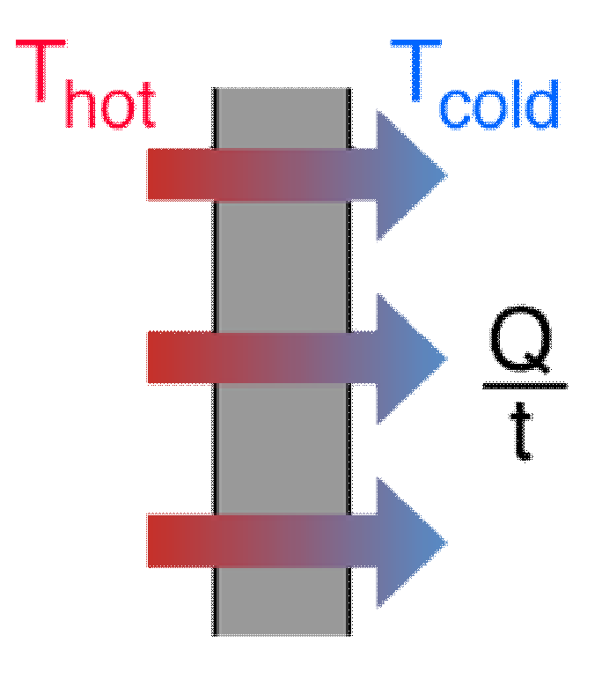= thermal conductivity of the barrier area



= temperature

= thickness of barrier

The thermal energy radiated by a blackbody radiator per second per unit area is proportional to the fourth power of the absolute temperature and is given by



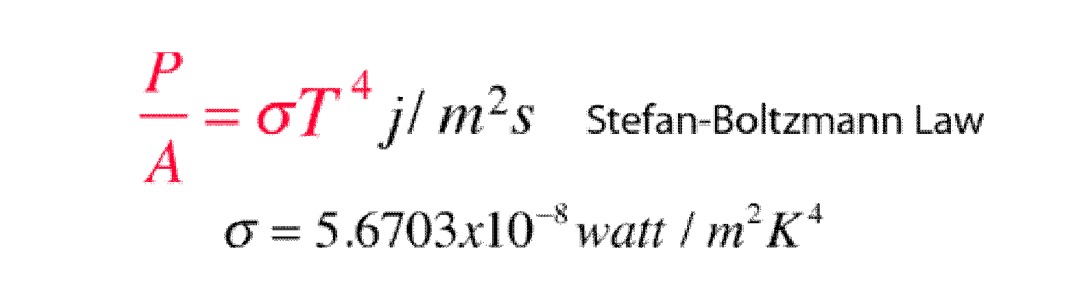

For hot objects other than ideal radiators, the law is expressed in the for m:



where e is the emissivity of the object (e = 1 for ideal radiator). If the hot object is radiating energy to its cooler surroundings at temperature T c, the net radiation loss rate takes the form



The Stefan-Boltzmann relationship is also related to t he energy density in the radiation in a given volume of space.

# Heat Radiation

Thermal radiation is energy transfer by the emission of electromagnetic waves which carry energy away from the emitting object. For ordinary temperatures (less than red hot"), the radiation is in the infrared region of the electromagnetic spectrum. The relationship governing the net radiation from hot objects is called the Stefan-Boltzmann law:

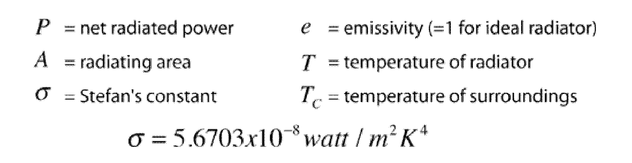



While the typical situation envisioned here is the radiation from a hot object to its cooler surroundings, the Stefan-Boltzmann law is not limited to that case. If the surroundings are at a higher temperature (TC > T) then you will obtain a negative answer, implying net radiative transfer to the object.

# Heat Convection

Convection is heat transfer by mass motion of a fluid such as air or water when the heated fluid is caused to move away from the source of heat, carrying energy with it. Convection above a hot surface occurs because hot air expands, becomes less dense, and rises . Hot water is likewise less dense than cold water and rises, causing convection currents which transport energy.

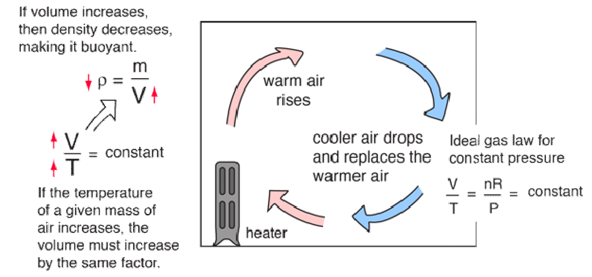

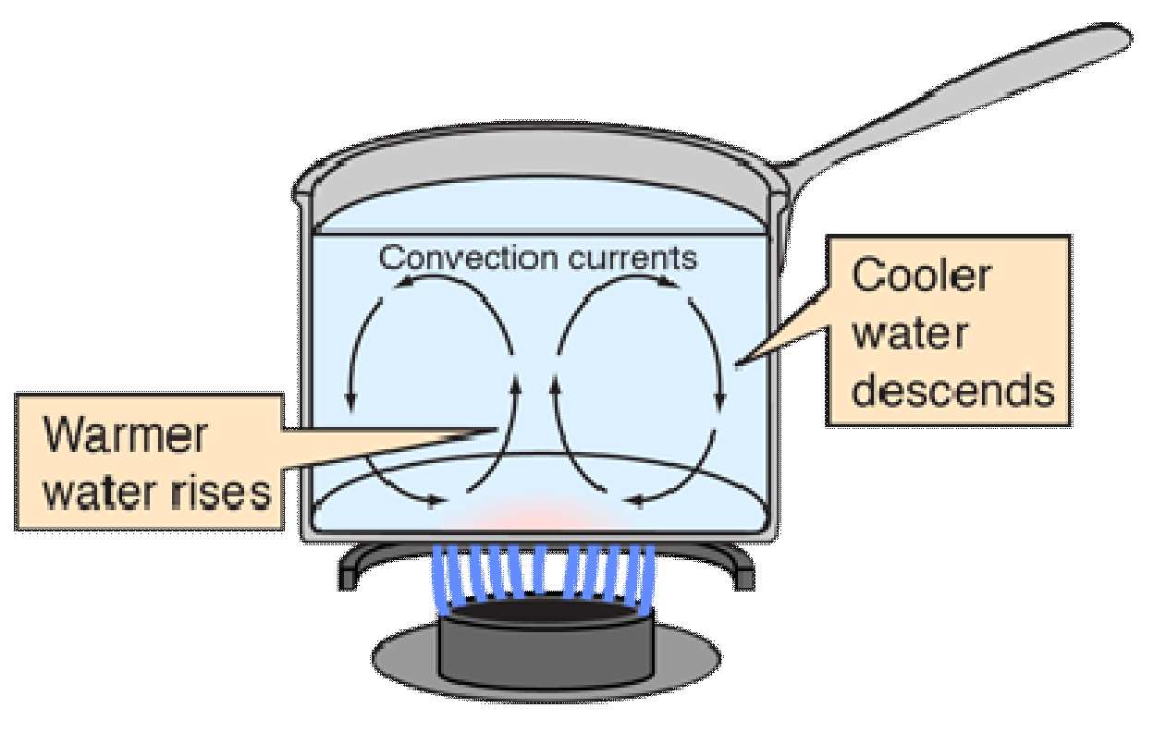Convection can also lead to circulation in a liquid, as in the heating of a pot of water over a flame. Heated water expands and becomes more buoyant. Cooler, more dense water near the surface descends and patterns of circulation can be formed, though they will not be as regular as suggested in the drawing.

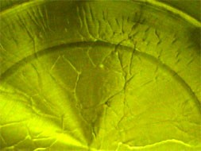Convection cells are visible in the heated cooking oil in the pot at left. Heating the oil produces changes in the index of refraction of the oil, making the cell boundaries visible. Circulation patterns form, and presumably the wall-like structures visible are the boundaries between the circulation patterns.

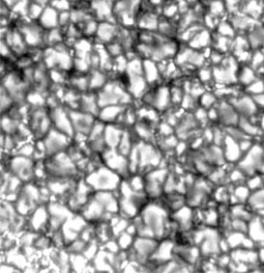Convection is thought to play a major role in transporting energy from the center of the Sun to the surface, and in movements of the hot magma beneath the surface of the earth. The visible surface of the Sun (the photosphere) has a granular appearance with a typical dimension of a granule being 1000 kilometers. The image at right is from the NASA Solar Physics website and is credited to G. Scharmer and the Swedish Vacuum Solar Telescope. The granules are described as convection cells which transport heat from the interior of the Sun to the surface.

In ordinary heat transfer on the Earth, it is difficult to quantify the effects of convection since it inherently depends upon small nonuniformities in an otherwise fairly homogeneous medium. In modeling things like the cooling of the human body, we usually just lump it in with conduction.

# Perspiration Cooling of Body







For 600 gm/day perspiration, cooling rate Q/t = 17 watts.



When the ambient temperature is above body temperature, then radiation, conduction and convection all transfer heat into the body rather than out. Since there must be a net outward heat transfer, the only mechanisms left under those conditions are the evaporation of perspiration from the skin and the evaporative cooling from exhaled moisture. Even when one is unaware of perspiration, physiology texts quote an amount of about 600 grams per day of "insensate loss" of moisture from the skin.

The cooling effect of perspiration evaporation makes use of the very large heat of vaporization of water. This heat of vaporization is 540 calories/gm at the boiling point, but is even larger, 580 cal/gm, at the normal skin temperature.



As part of the physiological regulation of body temperature, the skin will begin to sweat almost

precisely at 37°C and the perspiration will increase rapidly with increasing skin temperature. Guyton reports that a normal maximum perspiration rate is about 1.5 liters/hour, but that after 4 to 6 weeks of acclimatization in a tropical climate, it can reach 3.5 liters/hr! You would have to just sit around drinking constantly, just to keep from getting dehydrated! That maximum rate corresponds to a maximum cooling power of almost 2.4 kilowatts!

CELL TO CELL JUNCTION

Cell forms multi cellular vertebrates. To form tissues & organs cells organize into sheets During development, maintaining tissues in mature organism, cells express informational and junction molecules on their surface. As a result cells recognize and adhere to like cells.

# Cell – cell junctions – 3 functional types:-

* + - Occluding Junction / Tight Juncti on
    - Adhesive Junction / Anchoring Junction
    - Communicating Junction / Channel Forming Junction

# Occluding junctions / Tight junction:-

* + - Seal cells together in epithelial sheet.
    - Found hear free surface of cell.
    - Define apical, basal sides of epithelial cells.
    - Imp. In intestine, bladder, glands.
    - Segregate active, passive glucose transporters for directional glucose uptake from lumen of the gut.
    - Prevent passage of water and water soluble substances.
    - Responsible for electrical resistance across - epithelia.
    - Look like honey – comb.

# Adhesive junctions

* + - Adherens Junctions.
    - Desmosomes Junctions – due to association between to cadherin protein.

# Adherens Junctions

* + Hold cells in fixed position, tightly together, give mechanical strength.
  + Prominent in epithelial( covering) tissues **** Which is always subjected to stress.
  + Also found in cardiac nuscles **** always subjected to stress, cell layers covering organs, lining cavities.
  + Belt like junctions located just .below tight junction.
  + Cadherins cross pl. mem. and get linked to cytoskeleton by linker proteins.
  + Different cell types produce different types of cadherin proteins.
  + These junctions join actin bundles in one cell to actin bundles in an adjoining cell.
  + Cadherins linked actin microfilaments extend out of cel l and bind to cadherins of an adjoining cell.
  + These junctions form belt around cell, button like bundle.
  + Actin microfilaments can contract, therefore involved in invaginations during development.

# Desmosomes

* + Link intermediate filaments of adjoining cel ls.
  + Cadherins linked to keratin intermediate filaments inside the cell, then extend across the pl.mem. to associate with identical cadherins of an adjacent cell.
  + Cadherins and keratin filaments are anchored to a dense mixture of attachment proteins forming button like structure, called as plaque.
  + Present abundantly in skin, heart, neck of uterus **** at these places there is need of withstanding mechanical stress.
  + Also maintain cell position during development.

# Hemidesmosomes

* + Link keratin intermediate filame nts to basal lamina.
  + Integrins are linked to keratin filaments inside the cell and extend across the pl.mem to bind to lamina in the basal lamina.

# Communicating junctions:-

* + Direct connections between cytoplasms of adjoining cells.
  + Allow exchange of small molecules as signals between adjacent cells.

# Types:-

**Gap junctions:-**

* + Form channels across the pl. mem.s of adjoining animal cells.
  + Hexamer complex of proteins called connexon in each of two adjacent cells are aligned, forming an aqueous channel between them.
  + Opening of channel is regulated by cell.
  + Thro’ these channels usually rapid diffusion of small molecules and ions allowed.
  + Found commonly in smooth and cardiac muscles.
  + Blocking gap junctions can disrupt development..

# Plasmodesmata:-

* + Found in plant cells.
  + Form channel thro’ cell wall , connect adjoining cells.
  + Thro’ channel allow move. of metabolites, ions, hormones, proteins RNA.
  + Continuous connection of cytoplasm of adjoining cells.
  + Function – same as gap junction in animal cell.

# Cell Adhesion Molecules – (CAMs):-

* + CAMs allow cells to bind to other cells or to extracellular matrix.
  + Most imp. function in choreographing tissues and organ formation during embryogenesis.
  + Play imp. role in host defense, repair.

**Experiment**. – chick embryo dissociated into sing le cells, these cells placed in a culture dish.

**Observation** – strong tendency of cells to reaggregate into clusters based on their tissue of origin

**Conclusion** – specific adhesion mole. present in cell.

* + All adhesion mole. are integral membrane proteins
  + They have cytoplasmic, transmembrane, extracellular domains.
  + Cytoplasmic tail often interacts with cytoskeletal proteins which are actual anchors within the cell.

**Homophilic binding** :- Same type of adhesion molecules bind.

**Heterophilic binding**:- binding of different types of molecules or binding to an intermediary linker which it self binds to other adhesion molecules.

# Major Families:-

1. **Cadherins** – adhesion via homophilic binding between z cadherins in a calcium dependent manner. (therefore removal of extracellular Ca ++ disrupts binding) Play imp. role in segregating embryonic cells into tissues, in desmosomes, adherens junctions, cell adhesion by cadherins is thro’ cytoplasmic actin and intermediate filaments.
2. **Immuno globulin like adhesion molecules** – large gr. of molecules generated from a smaller no. of genes by alternative RNA splicing. Cause adhesion by both homophilic and heterophilic binding. Best e.g. neural cell adhesion molecules (N – CAMs)

**** predominatly expressed in nervous tissue, intercellular cell adhesion molecules. (I – CAM’s)

1. **Integrins** – large gr. of heterodimeric glycoprotiens, two subunits alpha and beta. Imp. in binding and interactions of cells with components of extracellul ar matrix. such as fibronectin. Imp. function – facilitate communication between cytoskeleton and extracellular matrix, allow each to influence orientation and structure of other. Imp. feature – some integrins exist in both active and inactive state. E.g. integrins responsible for binding of W.B.C. to endothelium are normally inactive, hence

W.B.C. circulate freely in blood, become active in response to inflammatory mediators, as a result W.B.C. pulled out from blood into inflamed tissues. If such integrins are less it results in abnormal inflammatory response in certain diseases.

1. **Selectins** – expressed primarily on leukocytes and endothelial cells. Imp. in many host – defense mechanism involving those cells. In contrast to other adhesion molecules, selectins bind to carbohydrate ligands on cell, the resultant binding forces are relatively week e.g. selectin mediated interactions between leukocytes and endothelial cells promote rolling of leukocytes along endothelium, while integrin binding allows leukocyt es to be stopped in place.

# * Functions of adhesion molecules are confirmed by spontaneous and induced mutations of their encoding genes.